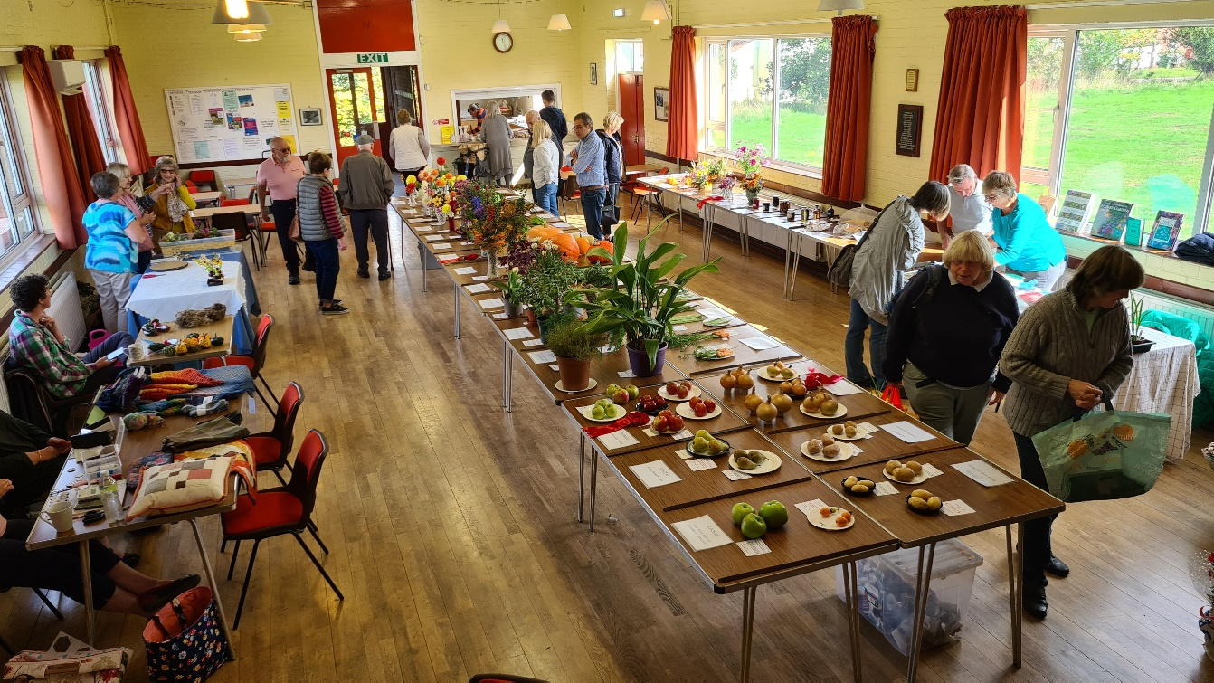

Fakenham Gardening Club
Schedules for 2026 Gardening Fayres

Sponsored by
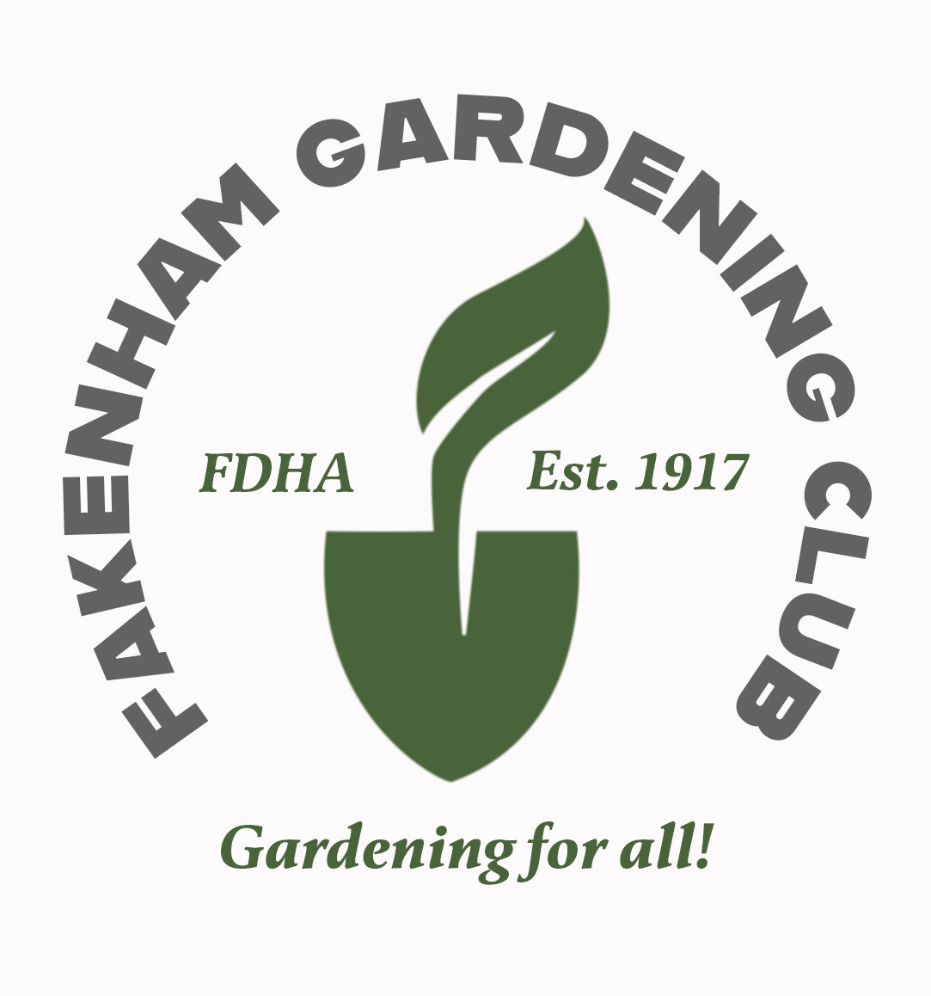

Schedule for Spring Gardening Fayre

Saturday 14th March 2026

Narcissi
- Vase of Five Stems of Trumpet Narcissi (Daffodil)
- Vase of Five Stems of Large or small Cup Narcissi
- Vase of Five Stems of Double Narcissi
- Vase of Five Stems of Small or Miniature Narcissi
- Vase of Five Stems of Multi-headed Narcissi
- Vase of Single Stem Narcissi any Type
- One pot up to 25cms of any Narcissi

Other Flowers
- Vase of Five Stems of Tulips
- One Pot or bowl of Bulbs /up to 25 cm excluding Narcissi or Daffodils
- Vase of Five Stems of Polyanthus
- One Pot or Bowl up to 20cm of Polyanthus
- One Pot or Bowl up to 20cm of Pansies
- Any Flower, one kind, outdoor not in schedule
- One Foliage Pot Plant /up to 25 cm
- One Flowering Pot Plant /up to 25 cm
- One Orchid

Ornamentals
- Vase of Mixed Foliage (Natural Sources only)
- Vase of Flowering Shrubs and Herbaceous Perennials (Natural Sources Only)

Flower Arranging
- An Exhibit of a table decoration 25cms x 25cms
- An Exhibit of the Joys of Spring, using Seasonal Flowers from any Source max. width 50cm

Photography
- Your interpretation of Spring – 8 x 6 mounted on white card

Garden to Table (Cookery)

Loaf of Bread
23. Norfolk Shortcake (4 pieces)
24. Jar of Marmalade

Schedule for Summer Gardening Fayre

Saturday 13th June 2026
Classes

Roses
- One stem any variety
- Bowl of Roses
- Vase of four Sprays
Sweet Peas
- Vase of Mixed Sweet Peas

Other Flowers and Ornamentals
- Vase of Mixed Flowering Shrubs and Herbaceous
- One Flowering Pot Plant max. 25cm pot
- One Foliage Pot Plant max. 25cm
- One Orchid
- Collection of four different varieties of Herbs displayed in a
Jam Jar

Fruit
10 A Dish of Mixed Fruit no less than three kinds
11 Six Strawberries with calyx and stalks
12 Six Raspberries with stalks
13 Six Gooseberries with stalks
14 Any fruit one kind not included in the schedule. Max. 4

Vegetables
15 Six Spring Onions
16 Six Pods of Peas
17 Six Pods of Broad Beans
18 Three Sticks of Rhubarb with 75mm leaf
19 Five Early Potatoes
20 One Cabbage with approx. 75mm stalk
21 One Lettuce with roots
22 Three Carrots with tops
23 Any Vegetable not included in the Schedule max. three
- Unusual Shaped Vegetable

Flower Arranging
25 An Arrangement reflecting a Celebration of Summer flowers 45cm footprint.
- An Arrangement in a Teacup and Saucer

Photography and Craft
27 Your Photographic Interpretation of ‘The Norfolk Coast’ mounted on white card max. 8”x 6”
28 Handmade Craft item your interpretation of ‘The Norfolk Coast’

Garden to Table (Cookery)
29 A Victoria sponge
30 Five fruit scones
31 Five cheese straws
32 A jar of jam/preserve made with seasonal fruit

Schedule for Autumn Gardening Fayre Saturday 26th September 2026
Dahlias
- One Dahlia any Variety
- Three Dahlias same Variety
- Three Dahlias from three Varieties
- Vase of Mixed Dahlias
5 One dahlia bloom, giant, more than 25cms diameter shown on stem.
6 Three Pom Poms
7 Three Bedding Dahlias

Chrysanthemums
8 One Chrysanthemum any Variety
9 Vase of Mixed Chrysanthemums

Flowers and Ornamentals
10 Vase of Mixed Hardy Herbaceous Perennials and Shrubs
11 Vase of Three Roses
- Pot or Bowl of flowering Begonias (any type container grown)
- Vase of herbaceous Salvias
- Vase of Michaelmas Daisies (up to 30cms)
- Vase of Three Pinks Single Bloom with Bud
- One Flowering Pot Plant max. 25cm pot
- One Foliage Pot Plant max. 25cm pot
- One Orchid
- One Cactus or Succulent

Fruit
20 Three Dessert Apples
- Three Dessert Pears
- Any Fruit not included in Schedule max three.

Vegetables
24 Three White Potatoes
- Three Red Potatoes
- Three Onions over 250gr
- Three Onions under 250gr
- Three Beetroots with tops
- Three Carrots with Tops
- Six Runner Beans any variety
- Longest Runner Bean
- One Cabbage Red or White with 75mm stalk
- Three Leeks with Leaves and cleaned roots
- One Pumpkin or Squash
- Three Parsnips with Tops
- Three Courgettes (max length 15cms)
- One Lettuce with Roots
- Five Tomatoes more than 40mm diameter
- Five small Tomatoes less than 40mm diameter
- One Truss of Tomatoes
- Any Vegetable not included in Schedule max. Three

Photography and Craft
42 One Fruit or Vegetable Character
- Fakenham’s architecture, a photograph on white card max. 8”x 6 “
- A Craft Item Reflecting Autumn. Any Medium except
Photography

Flower Arranging
45 Exhibit of Grasses and Seed Heads max. 45cm overall
46 Exhibit ‘Portrait of Autumn’ max.45 cm overall

Garden to Table
47 One Jar of Homemade Jam
48 One Jar of Homemade Pickles
- One Jar of Homemade Chutney
- One Small Bottle of Homemade Liqueur (no Kits)
- Chocolate brownies (6)
- Banana loaf
- Cheese scones (4)

HOW TO ENTER
ONE exhibit per Exhibitor is allowed for each class. Except for the Spring Gardening Fayre where we are allowing a maximum of 2 entries per member
- To ensure your entry is included, please send a complete list of all your exhibits to the Exhibits Secretary by 8:00 pm on the Thursday before the Fayre. You can email exhibitsfgc@gmail.com or call 07415 050 183. Late entries may be accepted on the day between 09:00 and 09:45 am if space allows. Please note that no late entries will be accepted after 09:45 am, as judging preparation begins promptly at 10:00 am. If you have any questions about your entry, please feel free to contact the Exhibits Secretary—whose decision on entries will be final.
- Include your name, Membership number (if applicable), and contact details at the top of your email. List the Class numbers you want to enter in numerical order. Each Exhibitor may submit one exhibit per class, except at the Spring Fayre. Non-members can enter their first exhibits but must become members to enter future Fayres.
- Please remember to arrive with your entries at Hempton Memorial Hall on Saturday morning, between 09.00 and 09.45 am. After you have handed in your exhibits, all entrants are required to leave the Hall while judging is in progress. The judge’s decision is final. Once judging is complete, entrants may return to Hempton Memorial Hall at 11.00 am to view the results and collect their entries; please do not enter the hall before this time.
If you are joining us for the first time, friendly volunteers will be available at the entrance to assist you with your entries and answer any questions.
NOTES ON ENTRIES
  - All exhibits in every class must be grown or produced by the entrant.
  - Vegetable exhibits must be cleaned and stripped of unnecessary leaves and stalks, unless otherwise stated in the schedule.
  - All pot plants must have been in the exhibitor's care for at least three months.
  - Exhibitors are encouraged to name varieties; however, errors in naming will not disqualify an entry.

Definitions:
  - Bowl: A hollow, rounded, cup-shaped container.
  - Vase: A vessel with a greater height than width.

The Fayre will be open to the public from 11.00 am, there will be informal workshops and demonstrations on a variety of topics. Refreshments and the 'On the Spot' Tombola will be available from 11.00 to 2.00 pm.

Spring Gardening Fayre 2026 Exhibit Entry Form
Name Membership Number
1 | 2 | 3 | 4 | 5 | 6 | 7 | 8 | 9 | 10
11 | 12 | 13 | 14 | 15 | 16 | 17 | 18 | 19 | 20
21 | 22 | 23 | 24

Total intended entries
Summer Gardening Fayre 2026 Exhibit Entry Form
Name Membership Number
1 | 2 | 3 | 4 | 5 | 6 | 7 | 8 | 9 | 10
11 | 12 | 13 | 14 | 15 | 16 | 17 | 18 | 19 | 20
21 | 22 | 23 | 24 | 25 | 26 | 27 | 28 | 29 | 30
31 | 32

Total intended entries

Autumn Gardening Fayre 2026 Exhibit Entry Form
Name Membership Number
1 | 2 | 3 | 4 | 5 | 6 | 7 | 8 | 9 | 10
11 | 12 | 13 | 14 | 15 | 16 | 17 | 18 | 19 | 20
21 | 22 | 23 | 24 | 25 | 26 | 27 | 28 | 29 | 30
31 | 32 | 33 | 34 | 35 | 36 | 37 | 38 | 39 | 40
41 | 42 | 43 | 44 | 45 | 46 | 47 | 48 | 49 | 50
51 | 52 | 53

Total intended entries

